# Department of Computing

# Fundamental of Computer Programming

# Class: SE-7B

# Lab 10: While Loops

# Date: 21th December, 2016

# Time: 2pm-5pm

# Instructor: Muhammad Muddasir Malik

# Lab 10: While Loops

# Introduction

A loop statement allows us to execute a statement or group of statements multiple times and following is the general form of a loop statement in most of the programming languages: C programming language provides the following types of loop to handle looping requirements.

**Tools/Software Requirement**

Python IDLE

**Description**  
  
WHILE - WHILE loops are very simple. The basic structure is   
  
while ( condition ) { Code to execute while the condition is true } The true represents a boolean expression which could be x == 1 or while ( x != 7 ) (x does not equal 7). It can be any combination of boolean statements that are legal. Even, (while x ==5 || v == 7) which says execute the code while x equals five or while v equals 7. Notice that a while loop is like a stripped-down version of a for loop-- it has no initialization or update section. However, an empty condition is not legal for a while loop as it is with a for loop

**Tasks:**

1. Write a program that inputs a sequence of 10 numbers into a list, and determines and prints the largest of the numbers and its location within the list.
2. Use list to solve the following problem. Read in 20 numbers, each of which is between 10 and 100, inclusive. As each number is read, print it only if it is not a duplicate of a number already read. Provide for the “worst case” in which all 20 numbers are different. Sample output is as following:

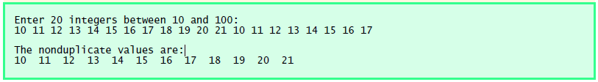

1. Read two 3x3 matrices from the user and find their product. Print the original matrices and the product on the screen.
2. Read the size of the matrix from the user. Populate it with data from the user. Print the original and the transpose matrices on screen.